Homework 3
Amin Majdi
ID: 01924731
1 Cascading Behavior in Networks

1. Find a set of three nodes in the network with the property that if they act as the three initial adopters of A, then A will spread to all nodes. (In other words, find three nodes who are capable of causing a complete cascade of A.)
If we turn 6, 7 and 11 to A, cascading will happen in the network.

2. Is the set of three nodes you found in (1) the only set of three initial adopters capable of causing a cascade of A, or can you find a different set of three initial adopters who could also cause a cascade of A?
Any combination of [4 or 6],[7 or 9]and [11 or 16] can make the cascading happen. So there are 8 different combination of 3 initial nodes that can make the cascade happen.
3. Find three clusters in the network, each of density greater than 1/2, with the property that no node belongs to more than one of these clusters.
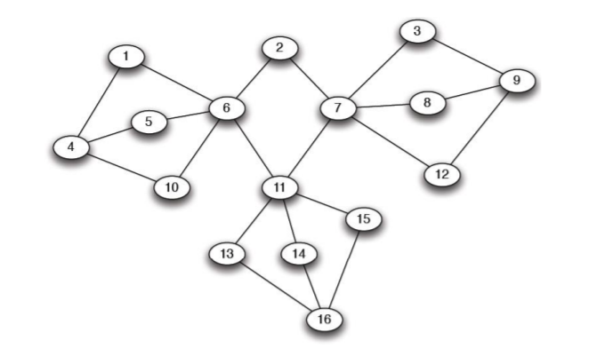

The 3 clusters with the density 3/5 are [1,4,5,6,10] , [3,7,8,9,12] and [11,13,14,15,16]. node #2 is a single node that is not in these clusters.

4. How does your answer to (3) help explain why there is no set consisting of only two nodes in the network that would be capable of causing a complete cascade of A?
We know that the cascading stops when it runs to a cluster with density grater than (1-q). In these example 1-q=1/2 which is less than density of these three clusters. So, diffusion to these clusters can not happen. So, at least we need to flip one of the proper nodes inside each of these clusters to have a full cascade. That’s why we can not have a full cascade by two initial nodes.

2 Centrality & Clustering
Consider a complete graph with n nodes.
1. Compute normalized degree centrality for each node as a function of n.
degree centrality for each node in the complete graph is n-1. Max degree centrality is also n-1. So the normalized degree centrality for each node will be (n-1)/(n-1)=1

2. Compute normalized closeness centrality for each node as a function of n.
Closeness centrality for each node in the complete graph is 1/(n-1). To have it normalized, we need to divide it by 1/(n-1). So, (n-1)/(n-1)=1 for all of the nodes in the complete graph.

3. Compute normalized betweenness centrality for each node as a function of n.
In a fully connected graph, the shortest path between two nodes is the link that connect them. So, the shortest path between node i and j will be ninj. Thus, there will be no node between any of the paths in the network. So the betweenness for all nodes will be 0. if we devide 0 to (n-1)(n-2)/2 the result will be still 0. so the normalized betweenness for the fully connected network is equal to 0.

3 Following the Crowd
In this question, we will ask whether an information cascade can occur if each individual sees only the action of his immediate neighbor rather than the actions of all those who have chosen previously. Let’s keep the same setup as in the Information Cascades model discussed in the class, except than when individual i chooses he observes only his own signal and the action of individual i – 1.

1. Briefly explain why the decision problems faced by individuals 1 and 2 are unchanged by this modification to the information network.
There is no one before the first person to take an action. So, he only have his own information. Also, second person can see the decision of the first person which is same as the previous configuration. So, the situation for the first two person is the same in these two configuration.

2. Individual 3 observes the action of individual 2, but not the action of individual 1. What can 3 infer about 2’s signal from 2’s action?
There are two case scenario: first, 2’s action is the same as 1’s action. Second, 2’s action is different from 1’s action . In both cases, 2 will pick his own action and will announce that as his signal. So, 3 will infer that 2 announce his own action regardless of 1’s signal. So, it is a perfect information.

3. Can 3 infer anything about 1’s signal from 2’s action? Briefly explain.
No, as I mentioned in the previous question, 2 will announce his own signal regardless of the signal of 1. So, 3 can not infer anything about 1’s signal based on 2’s signal.
4. What should 3 do if he observes a high signal and he knows that 2 Accepted? What if 3’s signal was low and 2 Accepted?
He should decide only based on his own signal. Because he does not know that 2’s action is same as 1’s action or not. So, the connection between 3 and 2 will be exactly like the connection between 1 and 2.

5. Do you think that a cascade can form in this world? Briefly explain why or why not (a formal proof is not necessary).
The cascade can not happen in this configuration because person n does not know anything about person n-2 all the way over. So, all the persons in line will have the same situation as person #2. So, their action will be their own observation and cascade will not happen.

